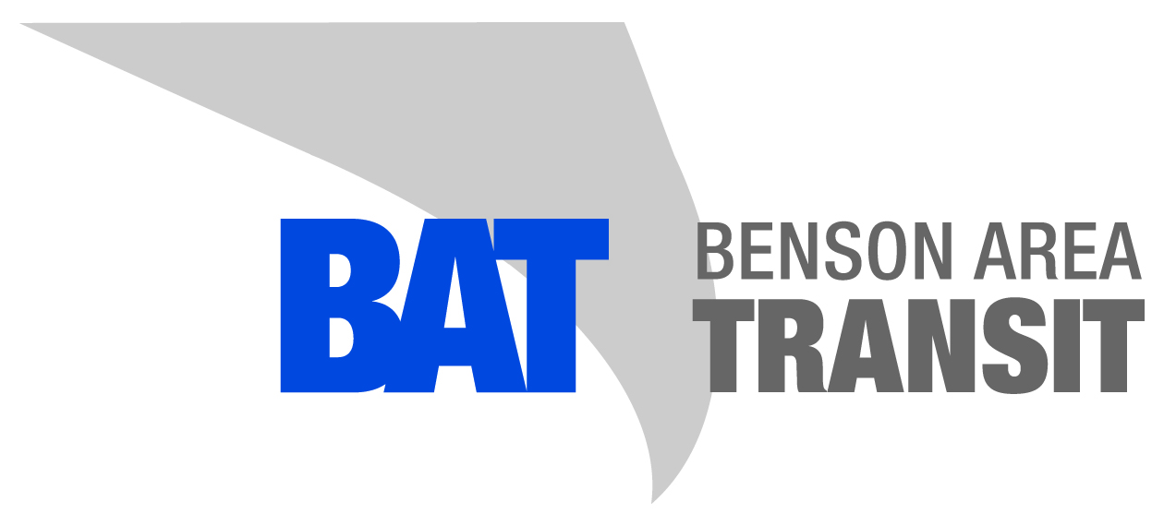

Passenger Safety Rules

- No eating, drinking, or smoking is allowed.
- Aisles are to be kept free of obstacles.
- Shirts and shoes are required.
- Special Needs Animals only.
- No fighting, pushing, throwing of objects, loud radios or vulgar language.
- Do not talk to the driver when the vehicle is in motion.
- Strollers must be folded up when boarding the bus.
- Children under 6 must ride with an adult.

